From <http://elainemeinelsupkis.typepad.com/building_for_the_future/2008/02/the-view-from-t.html>

Now, on to the next topic: why people can't talk about WWIII but will stake their lives on discussions that are fruitless about skyscraper architecture and jets:

[World Trade Center design.](http://upload.wikimedia.org/wikipedia/commons/thumb/6/69/World_Trade_Center_Building_Design_with_Floor_and_Elevator_Arrangment.svg/799px-World_Trade_Center_Building_Design_with_Floor_and_Elevator_Arrangment.svg.png) Click on image to enlarge:

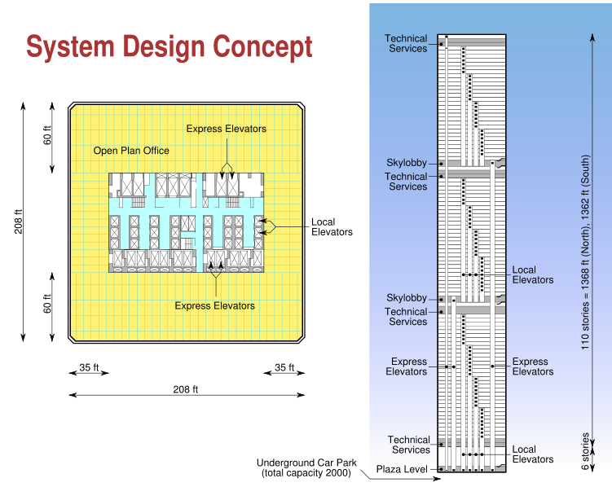

The WTC buildings were crummy buildings. The design was made so there were no interior walls connecting the outer skin to the inner core. As we can see here, there are NO internal supports. The steel beams holding the cement floors were very precariously attached at both ends to the inner and outer parts of the building. I am a person who likes multiple-level systems so the failure of one part doesn't turn things into a house of cards. More than once in my life, I have walked past scaffolding only to turn back and warn the people using it, they hadn't secured it sufficiently. Then, if I am ignored, the scaffolding eventually collapses. The World Trade Center was a new concept and alas, a very bad concept. The thought was, nothing could ever happen that would need interior walls to support the weight of the building in a failure. We know obviously that this is true. Far from being solid structures, they were very weak. The outer skin was not stone, brick, cement and steel with interspacing windows. It was all windows with little between these things. I marveled at this and it made me very queasy. From the first day David worked on the 64th floor of the North Tower, I began to talk to him about leaving. Which he finally did.

[Wikipedia:](http://en.wikipedia.org/wiki/Pan_Am_Building)

*The building was also known for its helicopter service to John F. Kennedy International Airport, a seven-minute flight that left from the rooftop helipad. This service was offered only between December 21, 1965 and February 18, 1968 and for a few months in 1977 and was ended after a spectacular accident that killed five people.[3][4] On May 16, 1977, a broken landing gear caused a parked Sikorsky S-61L with rotors still turning to tip over, killing four people who were outside the helicopter waiting to board, including exploitation filmmaker Michael Findlay. Part of a rotor blade sailed over the side of the building and killed a pedestrian on the corner of Madison and 43rd Street. Two other people were seriously injured.  
Another notorious moment in the building's history was Eli M. Black's historic suicide on February 3, 1975. The CEO of United Brands Company (now Chiquita Brands International) used his briefcase to shatter an external window and then jumped out of the forty-four story window to his death on Park Avenue. This incident was an inspiration for a similar suicide in the 1994 film, The Hudsucker Proxy.*

Modern buildings take advantage of lighter materials. But these are more vulnerable than older materials. Due to the nature of older brick, steel and mortar, the earlier sky scrapers like the one I worked in midtown, were far, far narrower and denser than the WTC or any of the other Trade Center buildings. When I worked in midtown, the government decided to begin again, the use of helicopters to fly people from the Pan Am building to Kennedy Airport. I had a bird's eye view of that helipad. Not only was it very noisy when I was trying to make international calls, it was nerve wracking. We always wondered if these would crash on us and one day, the blades flew off of one and killed a secretary. We all rose up in rage and demanded the city stop this madness. Whenever it was foggy, we would all remember how a WWII bomber flew into the Empire State Building after nearly clipping the building I was in. Being virtually at the top, I knew this was no small consideration. Recently, a Yankee picture [pitcher] plunged his plane into a building very nearby. But most of the midtown structures are older buildings. They don't have flat roofs. They are not solid windows. The new style is to have no exterior that is stronger than glass. So if anything were to slice into these buildings, they are destabilized. Unlike the older buildings.

[Beyond the Towers: Performance of Masonry  
By David T. Biggs, P.E., Ryan-Biggs Associates](http://www.cement.org/masonry/pp_fire_towers.asp)

*Comparing the present with the past in the world around us can be an important learning experience. Such was the case for the Federal Emergency Management Agency (FEMA) and the American Society of Civil Engineers (ASCE), in the difficult task of conducting an evaluation of the World Trade Center (WTC) and surrounding buildings.*

*The Event*

*On September 11, 2001, airplanes struck two 110-story office towers in New York and the Pentagon in Washington, D.C. The towers (WTC 1 and WTC 2) collapsed in less than two hours, and another building in the complex (WTC 7) collapsed later in the afternoon.* ***These buildings had few or no masonry components.*** *All of the surrounding buildings suffered damage from falling debris, wreckage, and fire from the towers. While the impact of portions of the collapsing buildings did the majority of harm, there was also damage from flying debris and air to the masonry used in their construction.*

Below is a diagram showing clearly how the floors are barely attached to anything, they had these small clips holding them up!

[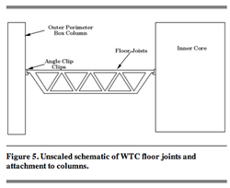](http://elainemeinelsupkis.typepad.com/.shared/image.html?/photos/uncategorized/2008/02/10/picture_8_2.png)

The WTC used to hold the record for the most cement used in a building. But due to its size, the mass of the cement wasn't as great as smaller buildings. But the volume was gigantic. When the structures failed, they rained many tons of dust, stone and metal upon all the buildings surrounding them. The weight of all this, when it landed on FLAT roofs, was very tremendous. The older buildings didn't have vast, flat roofs so they didn't suffer from this weight load.

[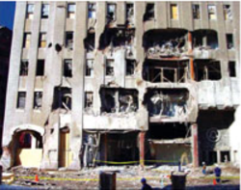](http://elainemeinelsupkis.typepad.com/.shared/image.html?/photos/uncategorized/2008/02/09/picture_6_2.png)

*Masonry Performance: Verizon Building, 140 West Street*

*One of the closest neighbors to the WTC site, the 30-story Verizon building, is a steel-framed brick building constructed circa 1924. The typical floors, composed of concrete-encased steel beams and girders, are redundant and robust. The exterior face of the perimeter framing is encased in brick and serves as both exterior wall and infill. Header bricks connect the exterior brick to the backup and support the weight of the exterior wythe. Columns are also brick encased.*

*The façade, floors, and framing of the south and east sides of the building sustained heavy damage, as did several exterior columns. Although the framing deflected as much as 2 ft into the building, the masonry infill restrained the columns from collapse. The steel structure was not affected. None of the damage threatened the structural integrity of the building. And although there was a substantial fire in WTC 7, there were no fires reported in this building. It was never out of service. The structure was shored and repaired.*

It is hard for people who are not experts to understand how fragile modern skyscrapers are. Much smaller buildings have caught on fire and not collapsed but then, they didn't have a huge hunk of the building's structure severed, first. And smaller planes cause smaller damage. There is no comparison with the WTC and the debris field this collapse caused. The only things that are similar are of course, nuclear bombs. But the failure of these buildings was probably inevitable since the structure was not aging well, in the first place. All buildings age and when the towers were going up, many of us said, 'How on earth can this be taken down safely?' I remember well, how the Port Authority said, the land around the Towers would be kept clear so that wouldn't be a problem. Only they didn't keep it clear at all, they kept building closer and closer and closer!

*Masonry improved the performance of the Verizon building because:*

*Perimeter brick masonry walls absorbed much of the impact from both WTC 1 and WTC 7, resulting in less damage to the steel structure.*

*Masonry infill of the exterior wall provided a redundant load path and helped prevent collapse.*

*Framing damage was localized, partially due to masonry infill.*

*Exterior brick headers held the upper brick from collapsing above a damaged section.*

*Brick encasement of the columns and concrete encasement of the steel framing provided fire and impact resistance.*

*Built-up sections appeared to be more ductile and better able to absorb energy along with the masonry infill.*

*The building did not experience fire damage—masonry and (safety glass) windows limited penetrations through exterior walls.*

Summary

In the towers themselves, the stairwell and elevator walls were constructed  
of gypsum products. Evidence indicates most of the floors of impact were  
damaged and rendered unusable. While it is presumptuous to assume that  
masonry enclosures would have survived the attacks, it is obvious that more  
durable wall systems would have improved chances for survival for occupants  
above the level of impact. Future research should be devoted to evaluating  
and developing durable, fire-rated egress enclosures for high-rise buildings.  
Reinforced masonry and concrete are two effective solutions that can be used  
without further development.

Example after example demonstrates how masonry helped prevent greater  
destruction during the World Trade Center disaster. Some of the lessons learned:  
Older framed buildings with masonry components performed generally better than newer buildings with lightweight curtain wall construction.

Masonry (walls, beams, partitions, infill) served as fireproofing and provided significant structural redundancy.

Masonry infill absorbed impact energy to minimize damage locally.

Masonry veneers and panelized systems are readily repaired.

Masonry proved in this event that it does more than simply enclose space; it  
provides fire protection, structural capacity, and even structural redundancy.  
It can provide safer enclosures for stairways or other exit routes, affording egress in high-rise buildings during emergencies.

The stairwells were built of SHEETROCK! Not cement. I remember those stairs and thought this was tacky back then. The lack of interior walls that were solid has much more to do with the collapse than anything else. These were bad buildings from day one. This is not unusual in architecture. For example, I had to fix many buildings in NYC that had 'cock-roofs'. This meant, a row of houses all had the same attic with no divisions. If one house caught on fire, they all burned. The city made this illegal long ago but the 'grandfathered' ones remained. And I would go in and build partitions. And these had to be fully fireproofed! Even small gaps had to be sealed carefully. We also know that houses in California with wooden fences are a danger to the neighborhood in places where the Santa Ana winds blow. Even today, such fences are still not outlawed. Though roofs made with wood are.

Buildings fail all the time. Bridges collapse. Dams give way. Space shuttles blow up. This is part of the hazards of life. But the thing we should worry about is how our leaders are leading us to possible wars. The level of complicity and carelessness or active engagement of the neo-cons and the Bushes in the 9/11 attacks cannot be proven unless we get ahold of all the classified documents and certainly, I call upon our government to release absolutely everything, all of it. But look at how long we had to wait for the Kennedy tapes! Over 30 years. Information about my father's activities in WWII weren't released until the mid-1980s. There is no excuse, none, for any of this secrecy!